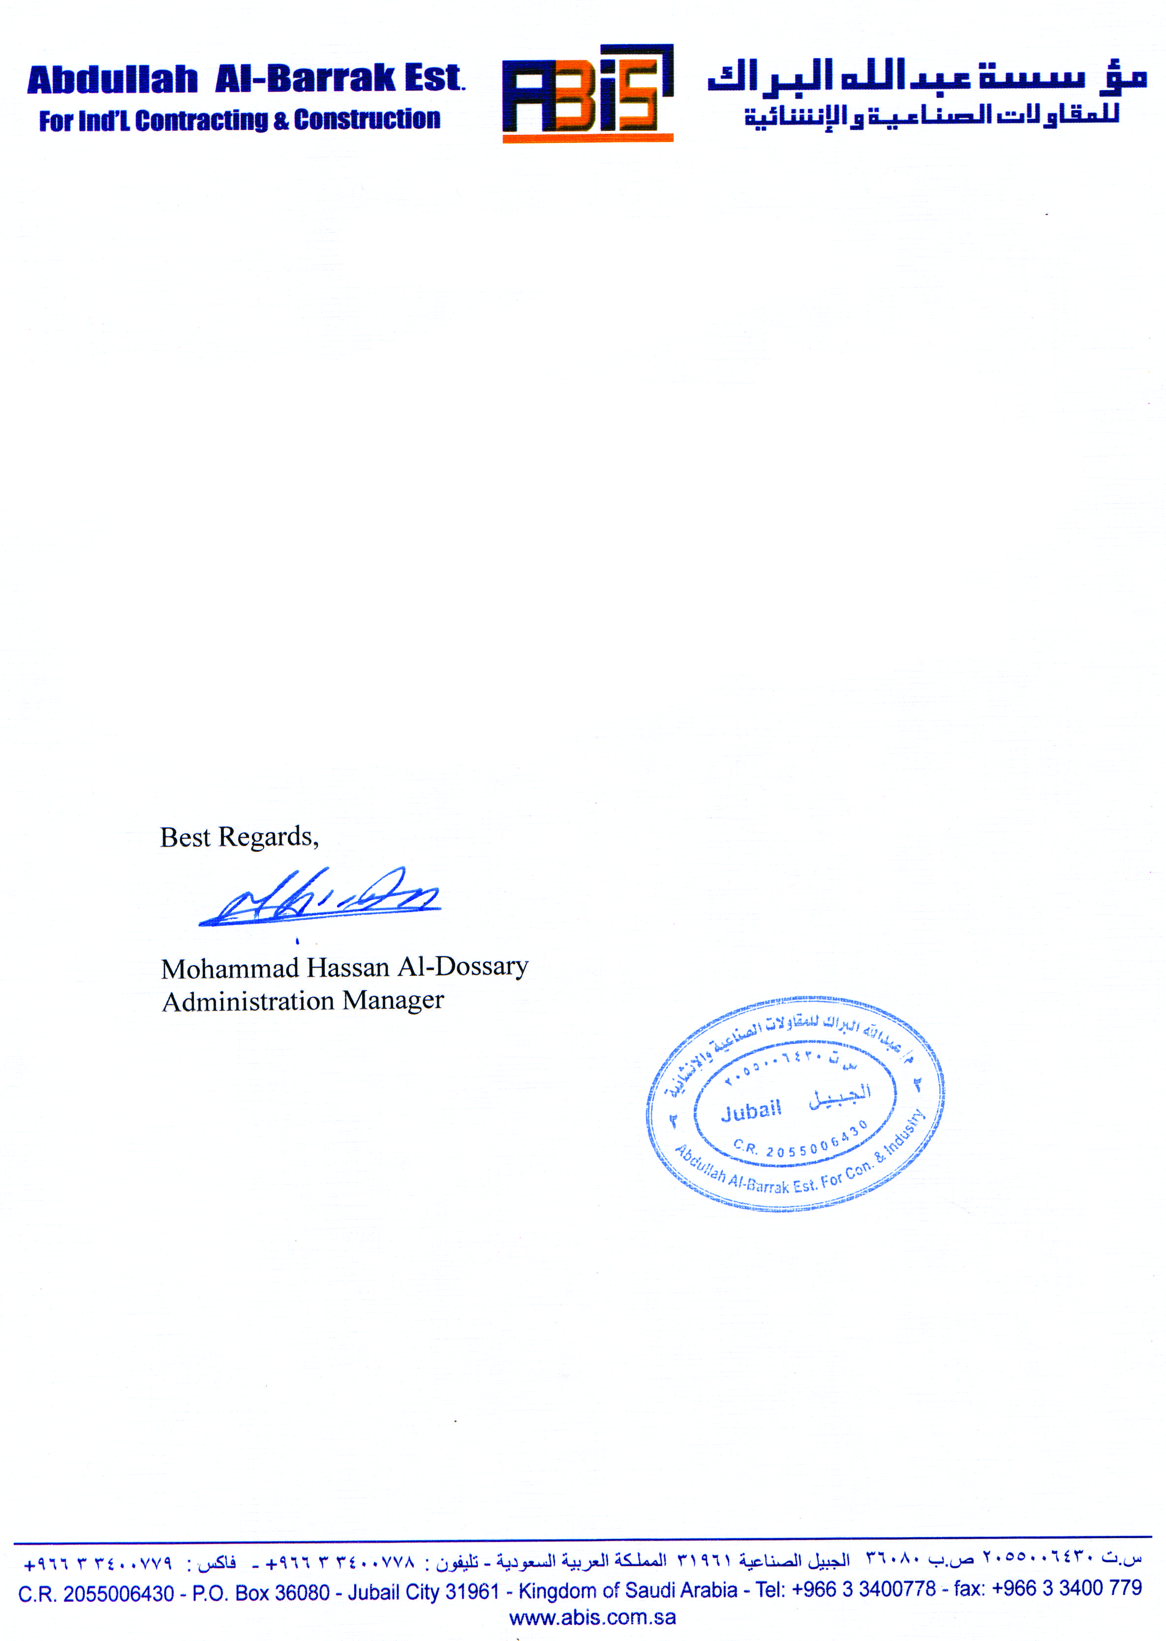

**CERTIFICATION**

This is to certify that Mr. <Name> with employee no. 3135, Pakistani national bearing Passport No. <Passport> was worked for Abdullah al-Barrak Est. For Industrial Contracting & Construction since <From2> to <To2> in capacity of <Designation>.

This certification is being issued upon his request for whatever legal purpose it may serve him best.

Issued <To2>.